Data Quality Plan

- Introduction
This Data Quality Plan intends to assess a subset of data collected by the Residential Property Price Register (RPPR). Within the sub-dataset, there are nine features (DateofSale(dd/mm/yyyy), Address, County, Eircode, Price, NotFullMarketPrice, VATExclusive, DescriptionofProperty, PropertySizeDescription) describing performance of residential properties purchase in Ireland from 2016 to 2024. This Data Quality Plan will provide detailed analysis on each feature, including: list the data quality issues, proposing potential solutions to these issues, and justifying the selected solutions. This plan aims to produce a final cleaned dataset with clearly defined feature types.

- Findings and Discussion
In this part of the Data Quality Plan, we will, by each feature, make a final decision on feature types, discuss identified issues, compare and choose the most appropriate solutions to those. Table 1 shows an overview of our assessment of each feature, which will be elaborated in this part.

  - DateofSale(dd/mm/yyyy)
The original DateofSale(dd/mm/yyyy) feature shows relatively high cardinality. It records the exact transaction date of each sale. On day level, we cannot aggregate trends. Such precision is not helpful for predictive modelling and may introduce noise to later analysis. Therefore, we propose two solutions to handle this high cardinality. First, we extract information on both month and year from the original feature DateofSale(dd/mm/yyyy), and focus on monthly-level analysis afterwards. Second, we group the original feature to quarterly or yearly time period to reduce cardinality.

After comparing the two solutions, we choose to proceed with the first solution: extract information on month and year from the original feature. Monthly aggregation provides a balance between cardinality of feature and sufficient information to observe trends in the residential property market. Compared with the second solution, monthly aggregation allows more precise analysis on trends and avoids losing too much information.

After applying the first solution, we remove the original DateofSale(dd/mm/yyyy) column and add SaleYear and SaleMonth as the result of our data cleaning. SaleYear and SaleMonth are both treated as categorical variables.

  - Address
Address feature also shows high cardinality as each transaction is linked to a specific address. Analyzing properties one by one is not robust enough to support meaningful market analysis. The large number of unique address values makes it difficult to identify broader geographic patterns within the dataset. Thus, we have two possible solutions to further discuss. First, we drop Address feature due to high cardinality, and use County and Eircode features together to provide regional information. Second, we initially group Address into Dublin and non-Dublin areas. For non-Dublin area, we use County feature as location markers. For Dublin region, we extract postal district information from the original Address feature.

After comparing the two solutions, we decide to adopt the second approach for the following reason. While dropping the Address feature simplifies the dataset, it may lead to loss of potentially valuable location information, particularly within Dublin where property prices may vary significantly across different postal districts. Also, using County feature instead, will lose the chance to compare trends and differences within Dublin. Eircode feature is reporting a missing rate of nearly 70%, making it hard to provide valuable analysis. Thus, combining County and Eircode features is not appropriate enough to provide robust research on location analysis. However, for the second solution, extracting Dublin postal districts and using County for non-Dublin areas, can preserve meaningful geographic granularity while still reducing the high cardinality of the original Address feature. This approach improves interpretability and allows more effective analysis of regional property market patterns.

When applying the second solution, we have similar rows as the result of initial extraction, for example, D7 and DUBLIN07, D1 and DUBLIN1. Under Irish context, we recognize that this represents the same district. So, we merge them together. Figure 1 shows the result of our final cleaning. From Figure1, we have Non-DUBLIN represents non-Dublin areas where detailed location information can be provided by County feature. For Dublin area, we have regional information within each postal district, from DUBLIN1 to DUBLIN24, while DUBLIN_OTHER refers to places we cannot extract district number from the original Address feature.

After applying the second solution, we setup a new feature Region to record the result of our data cleaning. New feature Region is viewed as a categorical variable.

  - County
The County feature is treated as a categorical variable, representing the administrative counties of Ireland. As pointed out in the Data Quality Report, this feature does not present significant data quality issues. There are no missing values, and the cardinality of the feature is 26, which aligns with the official number of counties in Ireland.

Given that geographic location plays an important role in residential property market analysis, this feature provides meaningful regional information for further investigation, especially for non-Dublin areas for the reason discussed above in the 2.2 Address section. Therefore, we decide to keep County feature in its original form with no extra transformation needed. Together with new feature Region, County feature will also serve as an important location indicator.

  - Eircode
For feature Eircode, we have identified several data quality issues in the Data Quality Report. First, the missing rate of this feature is 68.86%. Such a high proportion of missing values reduces the reliability of analyses based solely on this variable and limits its usefulness in providing location information. Second, the feature has a very high cardinality of 16,761, as each Eircode refers to a specific property location. This level of precision makes it difficult to identify broader regional patterns. Therefore, we consider several potential approaches to address these issues. First, we drop this feature due to high missing rate and high cardinality. Second, we try to fill in the missing part with information from Address feature. This may include call external APIs to map address with a certain Eircode.

After further assessing the second solution, we still find certain constraints. Specifically, there is limited open API that can provide the required mapping relationship. Moreover, even if we can fill in nearly 70% of missing data, we still need to aggregate to regional level to support later research, because Eircode refers to one single property. Plus, we have already done the regional aggregation in section 2.2 Address. In this way, we choose the first solution, drop Eircode feature, as the most appropriate action to this feature.

  - Price
The Price feature is finally treated as a continuous variable, representing the transaction value of residential properties. According to the Data Quality Report, the distribution of this feature is highly right-skewed, where most transactions fall within a moderate price range while a small number of observations show extremely high values.

These extreme values can significantly influence statistical analysis and the results of subsequent analysis or modelling. Therefore, we propose two possible solutions targeting at these issues. First, we clamp Price feature to the upper bound. Second, we apply a log transformation to the Price feature, which can help with the skewness and slightly reduce the influence of those extreme values.

After comparing the two approaches, we choose the clamping method. While log transformation can effectively reduce skewness, it also changes the original scale of the Price feature. Clamping, on the other hand, directly limits the impact of extreme values while preserving the original monetary scale, making the results easier to interpret and more suitable for further analysis. Also, since Price is our target value, keeping its original scale remains top priority.

When applying the clamping method, we follow the IQR-based methodology. To be more specific, from our dataset, we firstly identify 3,009 values higher than the upper bound. Then, we clamp these values to the upper bound. After this, we valid our implementation by checking that the maximum price, now, is equal to the upper bound value. Figure 2 displays price distribution after clamping. From Figure 2, we can see that extreme values above the upper bound have been capped, and the maximum value now equals the predefined upper bound. As a result, the current distribution becomes more stable and suitable for further analysis.

  - NotFullMarketPrice
NotFullMarketPrice feature is viewed as a categorical variable with binary values indicating whether a transaction was conducted at full market price. Based on findings from the Data Quality Report, this feature does not indicate significant data quality issues. There are no missing values and the feature contains only two possible categories, which keeps its cardinality low.

Although the majority of transactions occur at full market price, this variable still provides useful information about residential property transactions. Therefore, we decide to keep the NotFullMarketPrice feature without extra transformation for further analysis.

  - VATExclusive
Feature VATExclusive is treated as a categorical variable with binary values indicating whether the recorded transaction price excludes VAT. Based on findings from the Data Quality Report, this feature does not report significant data quality issues. There are no missing values and the feature contains only two possible categories, which keeps its cardinality low.

As VAT may influence the interpretation of property prices, particularly for newly built properties, this feature provides useful information when analysing the Price feature. Therefore, we decide to keep the VATExclusive feature in its original form for later research.

  - DescriptionofProperty
Feature DescriptionofProperty is viewed as a categorical variable, as it contains a limited number of predefined property types. According to the Data Quality Report, this feature does not have major data quality issues. There are three types of properties and there are no missing entries, indicating the feature is well-recorded within the dataset.

This feature provides meaningful information about the type of property involved in each transaction, which can be useful when analyzing transaction prices across different property types. Therefore, we decide to keep the DescriptionofProperty feature without applying additional transformations.

  - PropertySizeDescription
Feature PropertySizeDescription is considered as a categorical variable because it contains four size ranges of a property. However, according to the Data Quality Report, this feature reports a significant data quality issue: the missing rate is nearly 95%. Such a large proportion of missing values makes the feature unreliable for meaningful statistical analysis, because conclusions based on the remaining 5% of values cannot represent the overall dataset.

To address this issue, two potential solutions can be considered. First, we drop PropertySizeDescription feature from the dataset due to the lack of valid observations. Second, we keep this feature and treat the missing part as a separate category. In this way, the limited available information can be used in later analysis.

After comparing the two solutions, we choose to drop the PropertySizeDescription feature. Given the extremely high missing rate and the absence of reliable external data sources to recover the missing values, keeping the feature may introduce more noise than useful information. Dropping it helps maintain the overall data quality and prevents misleading conclusions in later research.

- Conclusion
This Data Quality Plan evaluates nine features from the Residential Property Price Register (RPPR) dataset and identifies several data quality issues that may affect further analysis. The main issues include high cardinality in DateofSale(dd/mm/yyyy) and Address features, a high missing rate in Eircode and PropertySizeDescription, and extreme values in the Price feature.

To address these issues, several data cleaning and transformation strategies are applied. The DateofSale(dd/mm/yyyy) feature is transformed into SaleYear and SaleMonth to reduce cardinality and to provide monthly aggregated analysis. Similarly, feature Address is extracted into a new Region feature to capture geographic patterns, particularly within Dublin. Features with limited analytical value, such as Eircode and PropertySizeDescription, are dropped due to high missing rates. In addition, extreme values in the Price feature are handled via an IQR-based clamping method to reduce the influence of outliers while maintaining the original scale of the variable.

After implementing these data cleaning solutions, the dataset now contains well-defined feature types and improved data consistency. Therefore, the cleaned dataset is more suitable for subsequent statistical analysis and modelling to capture and conclude on residential property market trends in Ireland.

Appendix

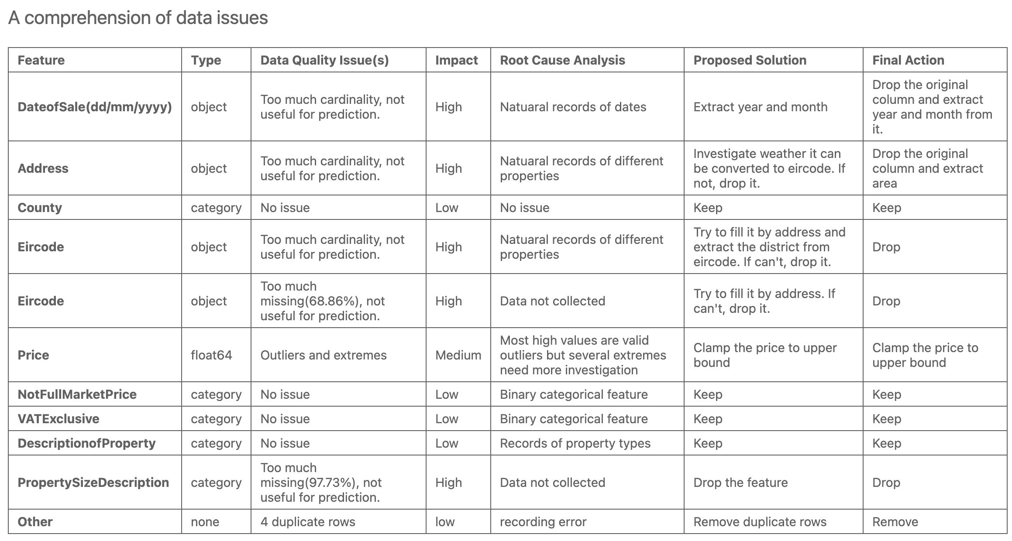
Table 1. An overview of data issues

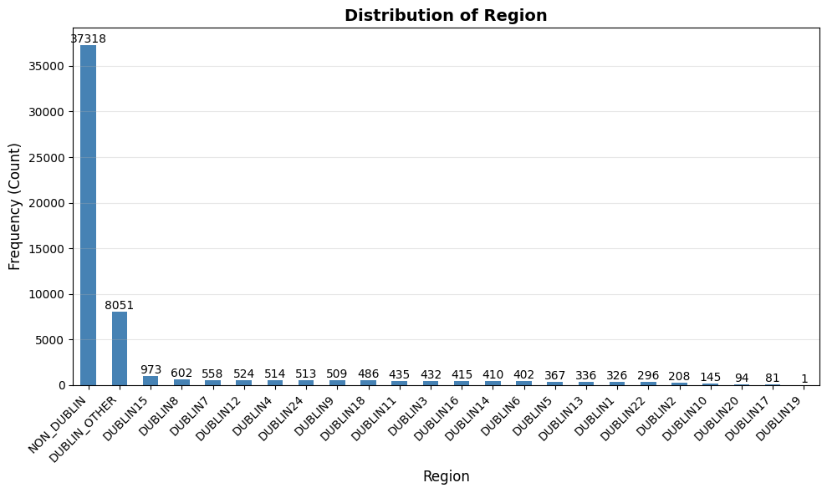
Figure 1. Distribution of Region

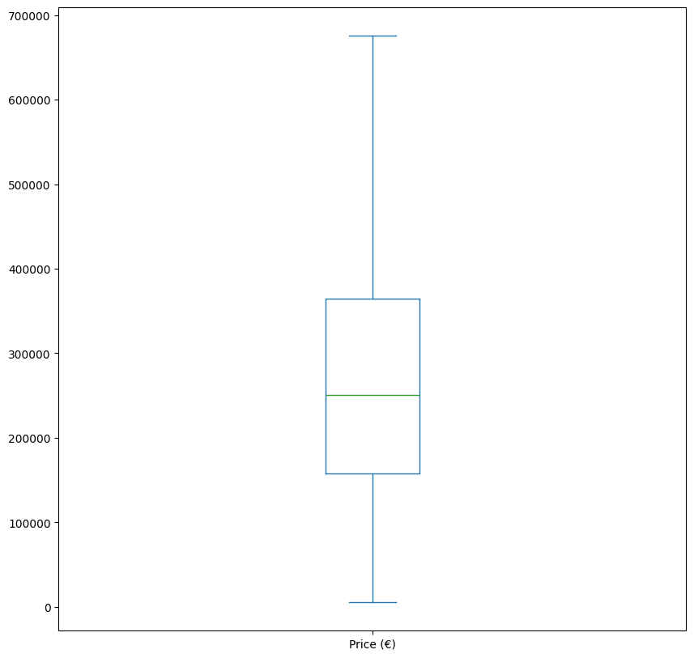
Figure 2. Boxplot after price clamping

